**BRAIN TUMOR DETECTION**

using Deep Learning

**Developed By : Team 16**

**Team Members : Nandini B , GousiyaBanu I , Harshita J R ,**

**Tejaswini Manne ,Rakshitha T M**

**Smart Bridge-Remote Summer Internship Program**

1. **INTRODUCTION**

Brain is the most complex organ of the body. The tumor is defined as uncontrolled growth of cells on any part of the body and respectively brain tumor is uncontrolled growth of brain cells . Different behavior of brain cells can cause different abnormalities which include Anaplasia, Atypia, Neoplasia and Necrosis leading to brain tumor . Brain tumor may or may not be symptomatic so they can be detected by symptoms exhibited by patients or can be identified on CT scan or MRI images . According to World Health Organization, brain tumor was detected in more than 22000 patients in America in 2016. “National Brain Tumor Society estimates that every year 13000 patients die and 29000 patients suffer from primary brain tumors” . World Health Organization reports states that there are 120 types of brain tumors which can be differentiated on the basis of size, shape, location and characteristics of brain tissue . Gliomas and glioblastomas are the most common type of brain tumors among others . Gliomas are further differentiated in two LGG as low-grade gliomas and HGG as high-grade gliomas whereas glioblastomas are more severe, life threatening and more frequent in adults aging from 40 to 50 .

The Average life expectancy of HGG patient is 14 months.Brain tumors are scaled from grade I to IV and they are further classified in benign (class I II) and malignant (class III IV) . Benign tumors are non-aggressive and mostly they don’t move from their infected area. Whereas, malignant tumors are aggressive and more fatal than that of benign tumors. They can grow enormously large and can move to any part of the body. Benign tumors are treatable through chemotherapy and they can be reduced to a smaller size . Reducing it to an extent where it can be removed through operation. On the other hand, malignant tumors are non-operable, but they can be reduced through chemotherapy to some extent . It may increase the life expectancy of the patient up to 2 or 3 months, but it is not completely curable . The only best way is the detection of the tumor in the early stages and nipping the evil in the bud. The most efficient and precise tool used to identify brain tumors is Magnetic Resonance Imaging known as MRI .MRI has a different type of models including T1-weighted MRI, T1c, T2-weighted MRI, T2-Flair, etc . Most expert radiologist recommend MRI for detection a brain tumor as it is more effective and accurate regarding shape, size and location of brain tumor . MR Images detects an identifies the type of a brain tumor. Benign tumors are basically confined to one specific area and they do not explicitly harm the structure of the brain . Converting MR Image into greyscale image where white part of the image describes the infected portion and greyscale portion shows the normal part of the brain. Detection of a benign tumor is relatively difficult from the detection of a malignant tumor . The reason behind it is the abnormality of the structure of the brain cannot be declared as benign tumor.

The structure of a normal brain can be different from the average structure without any reason. Identification and detecting the exact size, location and age of a brain tumor is solely dependent on skills and expertise of radiologist. Manual detection and classification of the brain tumor includes a lengthy manual procedure of radiologist with chances of human errors. By applying image processing with the help of machine learning algorithms, many researchers have proposed automated brain tumor detection and segmentation . Automated detection and segmentation of a brain tumor yields less time consuming, precise and efficient results. Researchers have proposed many algorithmic model approaches which are applied for image processing and identification of the brain tumor.

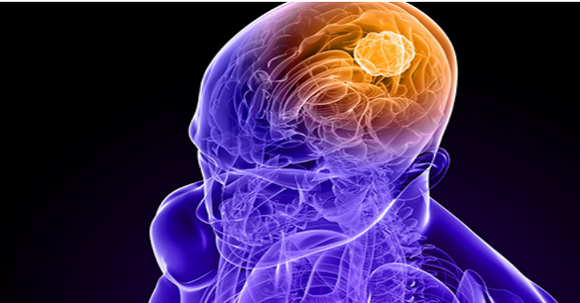

Fig. 1: Brain Tumor Location in Brain

These algorithmic models are classified into two categories: Generative and Discriminative. Generative models rely heavily on the basis of prior knowledge and use more of hand engineered components like Support Vector Machine (SVM) and other feature extraction techniques . Discriminative models have little prior knowledge and learn from the data given like Neural Networking, specifically Convolutional Neural Network (CNN) which is an efficient approach . Convolutional Neural Network is a cutting-edge method which is used for object and edge detection in images. In this paper after minimal preprocessing on MR images, CNN is applied as an approach to train an effective system which can identify and classify a brain tumor . CNN is a layered structure which involves kernels or filters that work in a pipe line method to extract multiple complex features.

After convolutional layer max pooling is applied, a fully connected layer yields all of the desired features . SoftMax is then applied to further detailed results. In order to build an efficient and healthy system, training data was augmented and properly labelled.

The formation of abnormal groups of cells inside the brain or near it leads to the initialization of a brain tumor. The abnormal cells abrupt the processing of the brain and a_ect the health of a patient . Brain imaging analysis, diagnosis, and treatment with adopted medical imaging techniques are the main focus of research for the researcher, radiologist and clinical experts .

**1.1 Overview**

Deep-learning-based techniques and methods are becoming popular in brain tumor segmentation studies, as their performance is superior in image analysis fields, such as object detection , image classification and semantic segmentation . Deep learning techniques have achieved state-of-the-art performance for automatic segmentation of brain tumors through multi-model MRIs. The Convolutional Neural Network (CNN) is a powerful method for image recognition and prediction. However, CNN is mostly used for brain tumor segmentation, classification, and prediction of survival time for patients .

More deep-learning-based methods that are utilized for tumor segmentation, classification, and prediction and By using the algorithm of a Flask model has been implemented and tested. Among all the deep learning methods and techniques, CNNs perform batter for image segmentation, classification, and prediction

**1.2 Purpose**

Our aim from the project is to make use of pandas, matplotlib, numpy,tensorflow,keras libraries from python to extract the libraries for deep learning for the brain tumor prediction.And in the end, to predict whether the person have brain tumor or not and withdrawing the conclusions.

1. **LITERATURE SURVEY**

Image segmentation plays a significant role in medical image processing as medical images have different diversities. For brain tumor segmentation, they have used MRI scan images. A technique called Enhanced Intelligent Scissors (EIS) is presented for segmenting areas of interest in medical images. The proposed algorithm specifies the issues that are associated with segmenting medical images and allows for fast, strong, and flexible subdivision without requiring true manual tracing. The boundary extraction problem is formulated as a Hidden Markov Model (HMM) and the present technique to the second-order Viterbi algorithm with state pruning is used to find the best boundary in a robust and efficient manner based on the pull out external and internal local costs, thus handling much inexact user boundary definitions than existing methods. Experimental results using MR images show that the proposed algorithm achieves accurate segmentation in medical images without the need for accurate boundary definition as per existing Intelligent Scissors methods. For usability testing shows that the proposed algorithm requires less user interaction than Intelligent Scissors.The main advantage of using the proposed approach of user interaction over the conventional IS approach is that the user does not need to trace around the boundary carefully. These methods are refined based on image gradients, making it highly sensitive to contrast non-uniformities typically found in medical images. MRI is most vastly used for brain tumor segmentation and classification. brought in the accuracy 97.87% with a split ratio of 80:20 of 217 images, i.e. 80% of training images and 20% of testing images. In the future, they have planned to work with brain images, achieve more efficient brain tumor segmentation. Working with a larger dataset will be more challenging in this aspect, and they have wanted to build a dataset emphasizing the abstract with respect to their country which will accelerate the scope of their work.

**2.1 Existing problem**

Now a days we have seen most of the tumors are life threatening where brain tumor being one of them.As we know that brain tumor can be of any shape , size , location and intensity , therefore it is very difficult to detect tumpor and diagnose it. The manual identification of tumor from MRI images is subjective in nature and many vary from expert to expert depending on their expertise and other factors which include lack of specific and accurate quantitative measures to classify the MRI images as it is brain tumor or not. So automated identification of brain tumor from MRI images help alleviating the major issuses and provide better results. Detection of brain tumor from the various symptoms of the patients has always been a major issue for the medical practitioner and pathologist for diadnosis and treatment planning. It is also fact that some tests may be time consuming and it gives workloads and difficulty for the pathologists to obtain the accuracy of the presence of the tumor.

* 1. **Proposed Solution**

Brain tumor at early stage is very difficult task for doctors to identify. MRI images are more prone to noise and other environmental interference. So it becomes difficult for doctors to identify tumor and their causes. So here we come up with the system, where system will detect brain tumor from images. Here we convert image into grayscale image. User has to select the image. System will process the image by applying image processing steps. We applied a unique algorithm to detect tumor from brain image. But edges of the image are not sharp in early stage of brain tumor. So we apply image segmentation on image to detect edges of the images. In this method we applied image segmentation to detect tumor. Here we proposed image segmentation process and many image filtering techniques for accuracy.

In this firstly we train the machine with some of the brain tumor images which predict that tumor is present or not.then the user can use this by giving image data so it can predict brain tumor is present or not.

**3. THEORETICAL ANALYSIS**

It is important to detect Brain tumor as early as possible. Manual detection of a cancer cell is a tiresome task and involves human error, and hence computer-aided mechanisms are applied to obtain better results as compared with manual pathological detection systems. In **deep learning**, this is generally done by extracting features through a convolutional neural network (**CNN**) and then classifying using a fully connected network. We have trained a convolutional neural network and obtained a prediction accuracy of up to 83.19%. CNN is a modified variety of deep neural net which depends upon the correlation of neighbouring pixels. It uses randomly defined patches for input at the start, and modifies them in the training process. Once training is done, the network uses these modified patches to predict and validate the result in the testing and validation process. Convolutional neural networks have achieved success in the image classification problem, as the defined nature of CNN matches the data point distribution in the image. As a result, many image processing tasks adapt CNN for automatic feature extraction.

**3.1 Block Diagram**

**Data Collection**

**Data Preprocessing**

**Model Building**

**Application Building**

Create Train and Test Folders

Create an HTML file

Import the ImageDataGenerator Library

**3.2 Software Designing**

Optimize and save the model

Train and Test the Model

Configure Learning Process

Adding Dense Layers

Adding CNN Layers

Initializing the Model

Importing the Model Building Libraries

Build Python Code

Apply ImageDataGenerator Functionality to Trainset and Testset

Configure ImageDataGenerator Class

* Jupyter Notebook Environment
* Spyder
* Deep Learning Algorithms
* Python(Sequential,Dense,Conv2D,MaxPool2D,Flatten)
* HTML
* Flask

We developed this braintumorr prediction by using the Python language, which is a high level programming language along with Deep Learning Algorithm such as CNN. For coding we used the Jupyter Notebook of Anaconda distributions and Spyder, an integrated scientific programming in python language. Flask is used as a user interface for the prediction. Hypertext Markup Language (**HTML**) is the standard markup language for documents designed to be displayed in a web browser.

**4. Experimental Investigation**

In our project, we have used the Brain tumor Dataset. This dataset contains two folders: test_set and training_set. In test_set folder, we have two categories called Yes and No, where, Positive has the images having Brain cancer and Negative has the images which doesn’t have breast cancer. Similarly in the training_set folder. Having 209 images belonging to 2 classes and 44 images belonging to 2 classes.

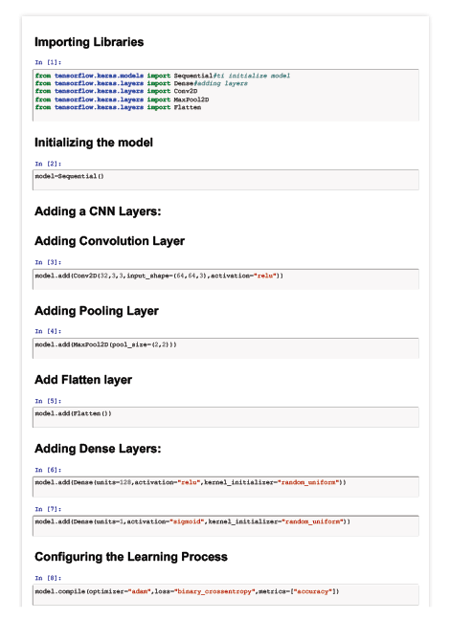

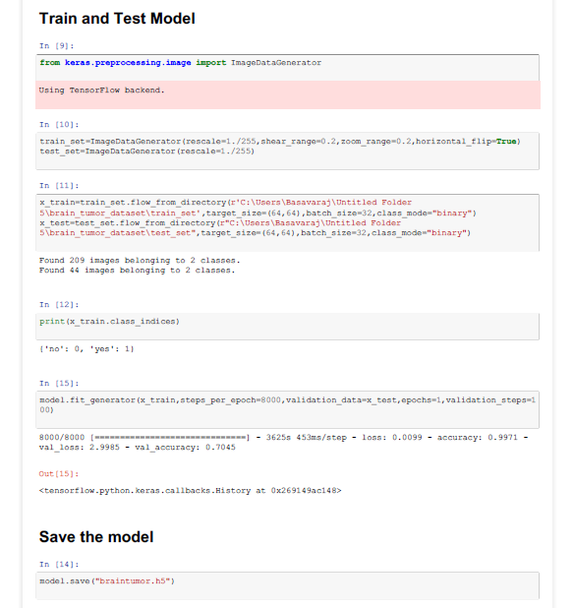

**5.FLOWCHART:**

START

CHOOSE THE IMAGES TO DO PREDICTION

DATABASE

DEEP LEARNING ALGORITHM LIKE CNN

DESIGNED MODEL

DECISION

No

Yes

DISPLAY RESULT

STOP

**6.RESULT**

In this paper, the CNN algorithm is used to predict its performance. The results show that,99.98% accuracy.

**Snapshots:** 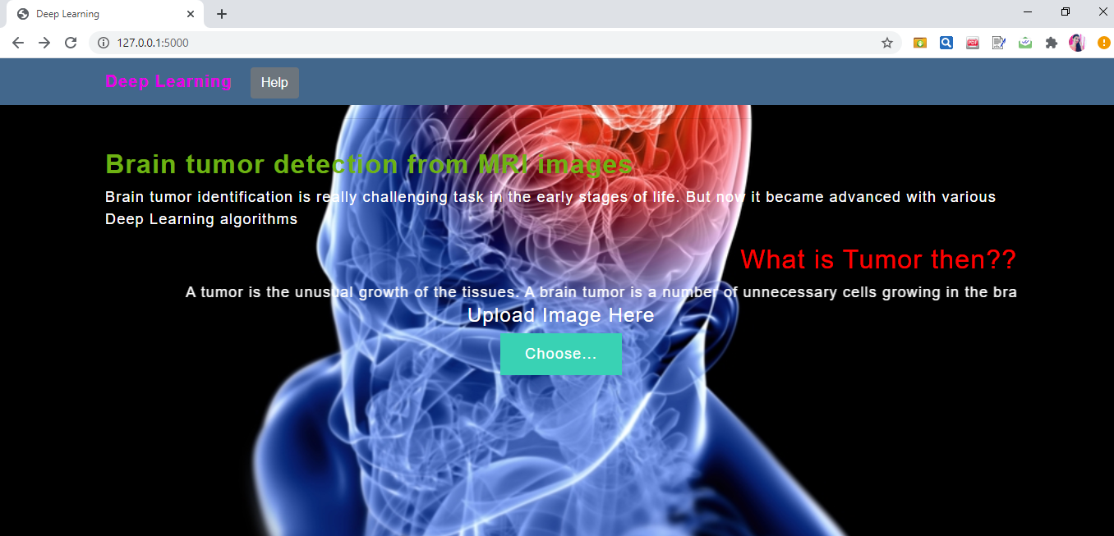

Fig:1-Home Page

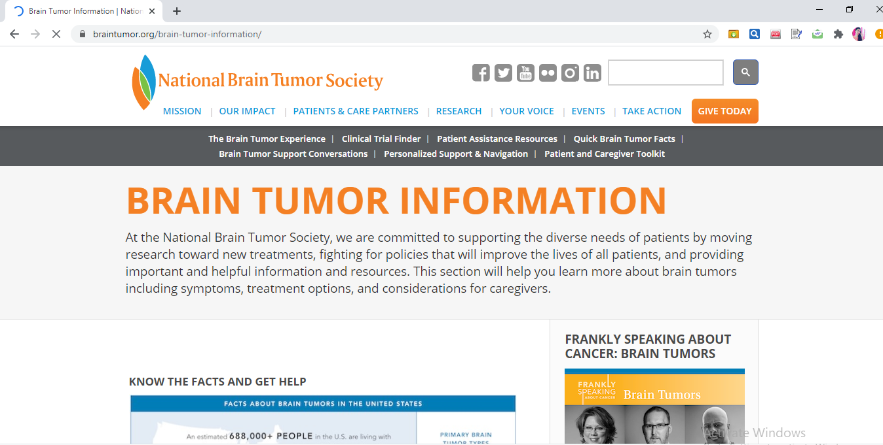

Fig:2-when you clicked on help it will redirect to <https://braintumor.org/brain-tumor-information/> this website.

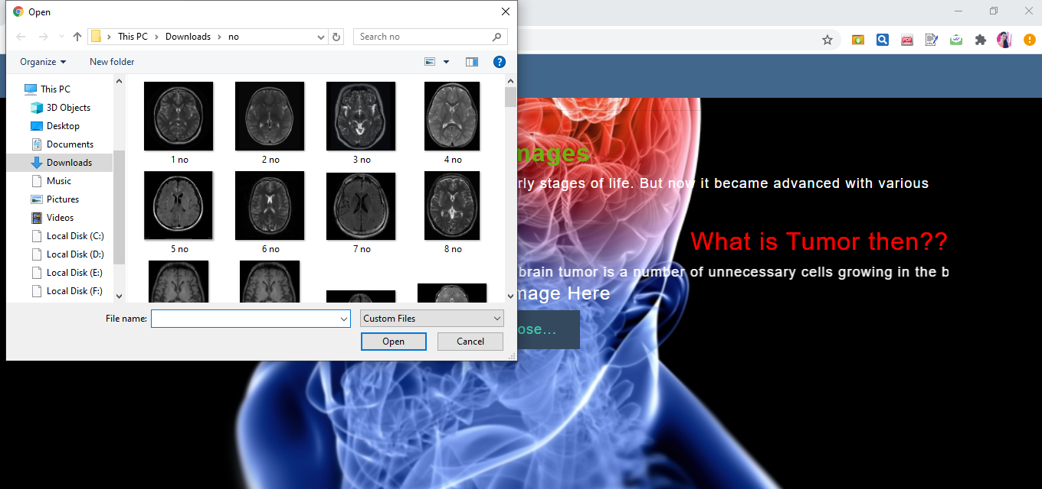

Fig:3-when you pressed choose, it will ask you to choose a file from the localhost.

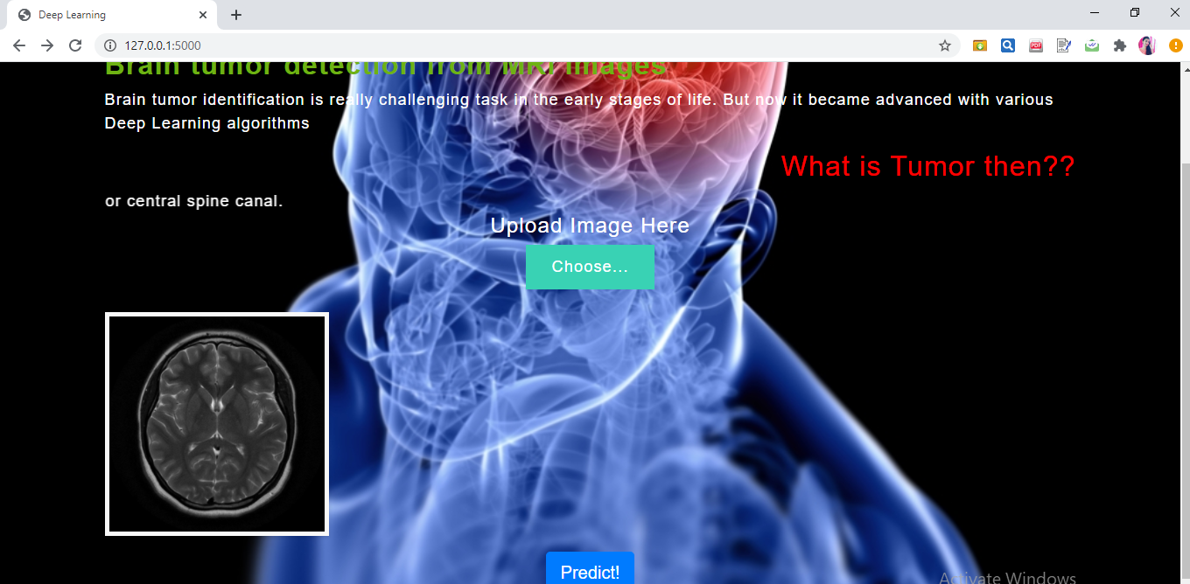

Fig:4-Selected image will be displayed

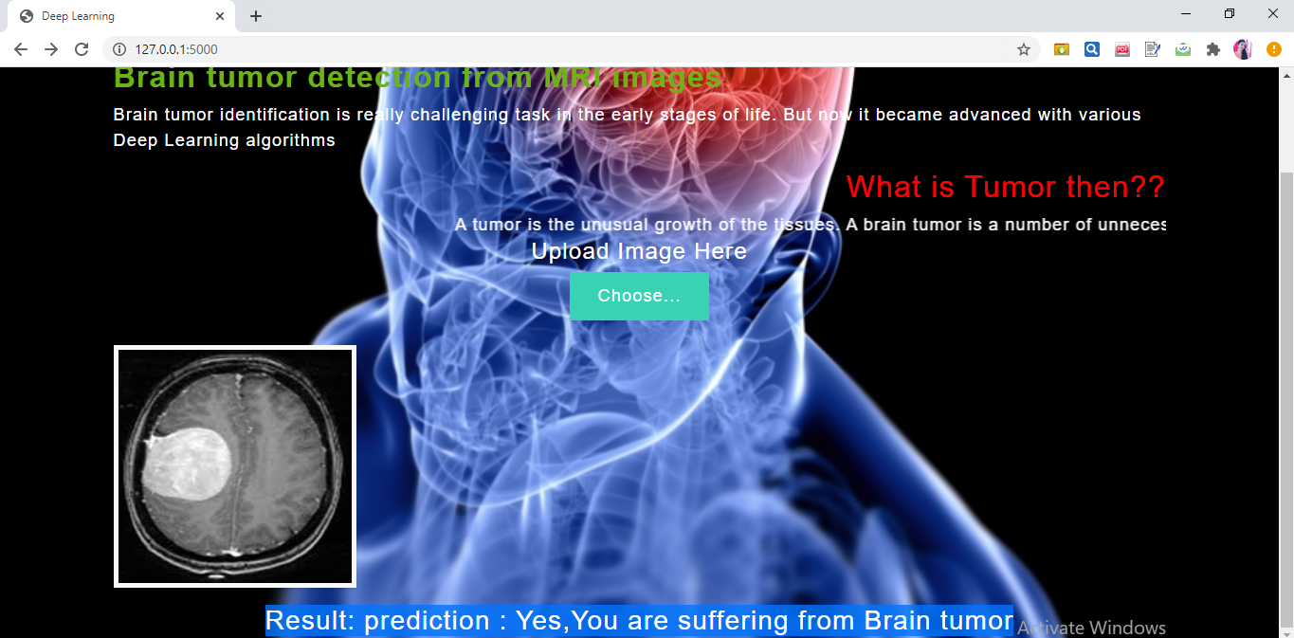

Fig:5-click on **predict** to see the output.If the person have Brain Tumor it display” **Yes,You are suffering from Brain** **Tumor**”.

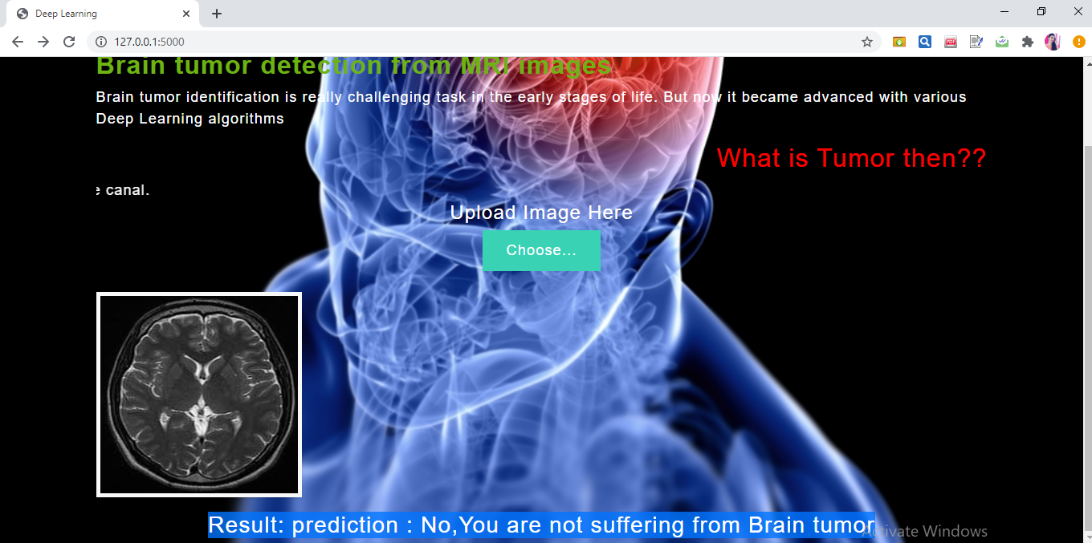

Fig:6-click on **predict** to see the output.If the person do not Brain Tumor it display” **No,You are not suffering from Brain Tumor**”.

**7. ADVANTAGES AND DISADVANTAGES**

**Advantages:**

1.Brain tumor detection is easy to implement and understand.

2.it operate in real-time due to low time complexity.

3.it is applicable in training and test-time

4.deliver invariance with respect to the lesion position,scale,and rotation.

**Disadvantages:**

1.it produces correlated images.

2.it easily generate anatomically incorrect examples.

**8.APPLICATIONS:**

1. “Brain Tumor Detection using Convolutional Neural Networks” simplifies the management process of brain tumor check-up by deploying a web interface to the users.

2. Fast processing and immediate results with high security.

3. Minimizing human effort and cost efficient databases.

4. Navigation through the site is easy.

**9.CONCLUSION:**

This projects consists of the details about the model which was used for the detection of brain tumor using the MRI images of the brain from the normal persons and the persons who had a brain tumor. From the resultant graphs, it is proven that the accuracy of the model has reached good level, if it is deployed in the real-time scenario then it will help many people in diagnosing the brain tumor without wasting the money on check-up. If the brain tumor is confirmed by the model, then the person can reach the nearest hospital to get the treatment. It can be the best way of practice for people to save money. As we know that the data plays a crucial role in every deep learning model, if the data is more specific and accurate about the symptoms of the brain tumor then that can help in reaching greater accuracy with better results in real-time applications.

**10.FUTURE SCOPE:**

There is a wide scope for future implementation of “Brain Tumor Detection using Convolutional Neural Networks” towards an interesting experience of modern technologies. Digital Platform is a ‘one stop shops’ for all kinds of Hospitals to serve the domestic and international users at any time, any moment and anywhere in any parts of the world. Not being sticky to make packages within India only, it can be global - a “global platform” through a comprehensive. In present days, modern technologies have made treatment more pleasure comprising speed with comfort. So, people are not willing to be bound within only a small geographical area, so there is place to make them experience the taste of “Global Platform”. It can be enhanced into a Mobile Application. And also in future we can create an Artificial Intelligence Deep Neural Network Model for the evaluation for all other kind of diseases and even we develop in such a way that all the small kind of diseases can be cured without contacting a doctor and by spending lot of money.

**11. BIBLIOGRAPHY**

1. Zhao, X.; Wu, Y.; Song, G.; Li, Z.; Zhang, Y.; Fan, Y. A deep learning model integrating FCNNs and CRFs for

brain tumor segmentation. Med. Image Anal. **2018**, 43, 98–111.

2. Singh, N.; Jindal, A. Ultra sonogram images for thyroid segmentation and texture classification in diagnosis

of malignant (cancerous) or benign (non-cancerous) nodules. Int. J. Eng. Innov. Technol. **2012**, 1, 202–206.

3. Christ, M.C.J.; Sivagowri, S.; Babu, P.G. Segmentation of brain tumors using Meta heuristic algorithms.

Open J. Commun. Soft. **2014**, 1, 1–10.

4. Singh, L.; Chetty, G.; Sharma, D. A novel machine learning approach for detecting the brain abnormalities

from MRI structural images. In IAPR International Conference on Pattern Recognition in Bioinformatics; Springer:

Berlin, Germany, 2012; pp. 94–105.

5. Charfi, S.; Lahmyed, R.; Rangarajan, L. A novel approach for brain tumor detection using neural network.

Int. J. Res. Eng. Technol. **2014**, 2, 93–104.

6. Logeswari, T.; Karnan, M. An improved implementation of brain tumor detection using segmentation based

on hierarchical self organizing map. Int. J. Comput. Theory Eng. **2010**, 2, 591.

7. Yang, G.; Raschke, F.; Barrick, T.R.; Howe, F.A. Manifold Learning in MR spectroscopy using nonlinear

dimensionality reduction and unsupervised clustering. Magn. Reson. Med. **2015**, 74, 868–878.

8. Yang, G.; Raschke, F.; Barrick, T.R.; Howe, F.A. Classification of brain tumour 1 h mr spectra: Extracting

features by metabolite quantification or nonlinear manifold learning? In Proceedings of the 2014 IEEE 11th

International Symposium on Biomedical Imaging (ISBI), Beijing, China, 29 April–2 May 2014; pp. 1039–1042.

9. Yang, G.; Nawaz, T.; Barrick, T.R.; Howe, F.A.; Slabaugh, G. Discrete wavelet transform-based whole-spectral

and subspectral analysis for improved brain tumor clustering using single voxel MR spectroscopy.

IEEE Trans. Biomed. Eng. **2015**, 62, 2860–2866.

10. Kleihues, P.; Burger, P.C.; Scheithauer, B.W. The new WHO classification of brain tumours. Brain Pathol. **1993**,

3, 255–268

11. Von Deimling, A. Gliomas; Springer: Berlin, Germany, 2009; Volume 171.

12. Mittal, M.; Goyal, L.M.; Kaur, S.; Kaur, I.; Verma, A.; Hemanth, D.J. Deep learning based enhanced tumor

segmentation approach for MR brain images. Appl. Soft Comput. **2019**, 78, 346–354.

13. Bauer, S.;Wiest, R.; Nolte, L.-P.; Reyes, M. A survey of MRI-based medical image analysis for brain tumor

studies. Phys. Med. Biol. **2013**, 58, R97. [

**APPENDIX**

**HTML FILE:**

<html lang="en">

<head>

<meta charset="UTF-8">

<meta name="viewport" content="width=device-width, initial-scale=1.0">

<meta http-equiv="X-UA-Compatible" content="ie=edge">

<title>Deep Learning</title>

<link href="https://cdn.bootcss.com/bootstrap/4.0.0/css/bootstrap.min.css" rel="stylesheet">

<script src="https://cdn.bootcss.com/popper.js/1.12.9/umd/popper.min.js"></script>

<script src="https://cdn.bootcss.com/jquery/3.3.1/jquery.min.js"></script>

<script src="https://cdn.bootcss.com/bootstrap/4.0.0/js/bootstrap.min.js"></script>

<link href="{{ url_for('static', filename='css/main.css') }}" rel="stylesheet">

<link rel="stylesheet" href="{{url_for('static',filename='css/main2.css')}}">

<style>

.moveright { text-align:right;}

bg-dark {background-color: #42678c!important;}

#result { color: #0a1c4ed1;}

</style>

</head>

<body>

<div style="background-image: url("https://www.matherhospital.org/wp-content/uploads/2017/09/brain-tumor-blog-photo.jpg");">

<nav class="navbar navbar-dark bg-dark">

<div class="container">

<div>

<a class="navbar-brand" href="#" style="color:rgb(230, 0, 230)"><strong>Deep Learning</strong></a>

<button class="btn btn-outline-secondary my-2 my-sm-0" type="submit">Help</button>

</div></nav>

<hr style="border:230px solid red,"/>

<div class="container">

<div id="content" style="margin-top:2em">{% block content %}{% endblock %}</div>

</div></body>

<footer>

<script src="{{ url_for('static', filename='js/main.js') }}" type="text/javascript"></script> </footer>

</html> {% extends "base.html" %} {% block content %}

<h2 style="color:rgb(110, 178, 19 )"><strong>Brain tumor detection from MRI images</strong></h2>

<p>Brain tumor identification is really challenging task in the early stages of life. But now it became advanced with various Deep Learning algorithms</p>

<h2 class="moveright" style="color:red">What is Tumor then??</h2>

<marquee behavior="scroll" direction="left" class="moveright">A tumor is the unusual growth of the tissues.

A brain tumor is a number of unnecessary cells growing in the brain or central spine canal.</marquee>

<h4 style="color:#FFA50">Upload Image Here</h4>

<div>

<form id="upload-file" method="post" enctype="multipart/form-data">

<label for="imageUpload" class="upload-label">

Choose... </label>

<input type="file" name="file" id="imageUpload" accept=".png, .jpg, .jpeg">

</form>

<div class="image-section" style="display:none;">

<div class="img-preview">

<div id="imagePreview"> </div>

</div>

<div>

<button type="button" class="btn btn-primary btn-lg " id="btn-predict">Predict!</button>

</div></div>

<div class="loader" style="display:none;"></div>

<h3 id="result"> <span> </span></h3>

</div>

{% endblock %}

**app.py file**

from __future__ import division, print_function

# coding=utf-8

import sys

import os

import glob

import numpy as np

from keras.preprocessing import image

from keras.applications.imagenet_utils import preprocess_input, decode_predictions

from keras.models import load_model

from keras import backend

import tensorflow as tf

global graph

tf.compat.v1.disable_eager_execution()

graph=tf.compat.v1.get_default_graph()

from skimage.transform import resize

# Flask utils

from flask import Flask, redirect, url_for, request, render_template

from werkzeug.utils import secure_filename

from gevent.pywsgi import WSGIServer

# Define a flask app

app = Flask(__name__)

# Model saved with Keras model.save()

model = tf.keras.models.load_model("models/braintumor.h5")

@app.route('/', methods=['GET'])

def index():

# Main page

return render_template('index.html')

@app.route('/predict', methods=['GET', 'POST'])

def upload():

if request.method == 'POST':

# Get the file from post request

f = request.files['file']

# Save the file to ./uploads

basepath = os.path.dirname(__file__)

file_path = os.path.join(

basepath, 'uploads', secure_filename(f.filename))

f.save(file_path)

img = image.load_img(file_path, target_size=(64, 64))

x = image.img_to_array(img)

x = np.expand_dims(x, axis=0)

with graph.as_default():

preds = model.predict_classes(x)

#index = ['No Tumor','Yes Tumor']

#text = "prediction : "+[preds[0]]

if preds[0][0]==0:

prediction="No,You are not suffering from Brain tumor"

else:

prediction="Yes,You are suffering from Brain tumor"

text = "prediction : "+prediction

# ImageNet Decode

return text

if __name__ == '__main__':

app.run(debug=False,threaded = False)